POCKETSMART AI
Your Smart Budget & Recommendation Assistant
PROJECT DOCUMENTATION
SmartBridge Project

Project Details | Information
Project Title | PocketSmart AI: Your Smart Budget & Recommendation Assistant
Project Type | Generative AI Web Application
Backend | FastAPI + Uvicorn
Frontend | HTML, CSS, JavaScript, Jinja2
AI Integration | Google Gemini API
Database | SQLite
Main Modules | Home Interior Planner, Party Planner, Jewelry Planner

Table of Contents
1. Project Overview
2. Problem Statement
3. Objectives
4. Proposed Solution
5. Scope of the Project
6. Technology Stack and Requirements
7. Project Folder Structure
8. System Architecture
9. Functional Modules
10. User Workflow
11. Database Design
12. Backend and API Implementation
13. AI Integration
14. Frontend Implementation
15. Authentication and Validation
16. Project Development
17. Testing and Validation
18. Screenshots and Output Evidence
19. Limitations
20. Future Enhancements
21. Conclusion
22. References

1. Project Overview
PocketSmart AI is a Generative AI-powered budget and recommendation assistant designed to help users plan lifestyle-related purchases and events within a defined budget. The implemented application provides Home Interior Planning, Party Planning and Jewelry Recommendations.
Users enter a budget and relevant preferences. The application validates the input, searches a grounded recommendation catalog, sends structured context to Gemini, normalizes the response, calculates estimated totals and remaining budget, and displays recommendations and budget allocations.

Implementation Note
The supplied SmartBridge reference document contains both Flask and FastAPI references. The actual supplied project files use FastAPI. The supplied configuration also uses the model value configured in the project environment. This documentation follows the actual project files.

2. Problem Statement
Users often need to compare products or services while staying within a fixed budget. Manual searching across different categories and platforms is time-consuming and makes budget organization difficult. PocketSmart AI provides a single interface for budget-based planning and structured recommendations.

3. Objectives
- Provide budget-aware recommendations for Home Interior Planning.
- Support Party Planning using budget, guest count, venue and preferences.
- Provide occasion- and style-based Jewelry Recommendations.
- Allow optional outfit image input for general jewelry colour/style coordination.
- Use Generative AI for structured recommendation generation.
- Maintain recommendation history for logged-in users.
- Provide registration, login, logout and session handling.
- Provide fallback recommendations when AI generation is unavailable.

4. Proposed Solution
- Open PocketSmart AI and select a planner.
- Enter the required budget and preferences.
- FastAPI validates the request using Pydantic schemas.
- The recommendation service searches the supplied catalog.
- Gemini receives the user context and grounded catalog information.
- The AI response is validated and normalized.
- Estimated total and remaining budget are calculated.
- Results are displayed with allocations, recommendations, notes and provider search links.
- Authenticated recommendation history is stored in SQLite.

5. Scope of the Project
Area | Implemented Scope
Home Interior | Budget, rooms, style, city, requested item categories and quantities.
Party Planning | Budget, guest count, event type, venue, city and preferences.
Jewelry Planning | Budget, occasion, style, metal, outfit description and optional outfit image.
Authentication | Registration, login, logout and session information.
History | Saved recommendation requests and responses for authenticated users.
Recommendation Data | Grounded catalog links and catalog prices; not live inventory.

6. Technology Stack and Requirements
Technology | Purpose
Python | Backend and application logic
FastAPI | Web/API backend
Uvicorn | ASGI server
Jinja2 | HTML template rendering
HTML / CSS / JavaScript | Frontend UI and dynamic results
Google Gemini API | Generative AI recommendations
Pydantic | Request/response validation
SQLite | User and recommendation history
python-dotenv | Environment configuration
pytest + httpx | Testing

7. Project Folder Structure
Actual supplied project structure
PocketSmart AI/
├── app.py
├── config.py
├── database.py
├── requirements.txt
├── README.md
├── .env
├── .env.example
├── .gitignore
├── models/
│ └── schemas.py
├── routes/
│ ├── auth.py
│ ├── pages.py
│ ├── planners.py
│ └── session.py
├── services/
│ ├── catalog.py
│ └── gemini_service.py
├── templates/
│ ├── base.html
│ ├── index.html
│ ├── login.html
│ ├── dashboard.html
│ ├── home.html
│ ├── party.html
│ ├── jewelry.html
│ └── 404.html
├── static/
│ ├── css/style.css
│ └── js/
│ ├── app.js
│ └── planners.js
└── tests/
└── test_app.py
File / Folder | Implementation
app.py | FastAPI app, CORS, static files, routers, startup and server entry.
config.py | Environment configuration and Gemini settings.
database.py | SQLite database and table creation.
models/schemas.py | Pydantic request and response models.
routes/ | Authentication, pages, planners and session endpoints.
services/catalog.py | Grounded recommendation catalog and search.
services/gemini_service.py | Gemini generation, structured output, retry, normalization and fallback.
templates/ | Jinja2 HTML pages.
static/ | CSS and browser-side JavaScript.
tests/test_app.py | Automated application/API tests.

8. System Architecture
The implemented system uses a modular FastAPI architecture. The browser communicates with FastAPI routes. Planner routes call catalog and Gemini services. Structured responses are normalized before being returned to the frontend. Authentication and history use SQLite.
System flow
User Browser
↓
Jinja2 / HTML / JavaScript
↓
FastAPI (app.py)
├── Page Routes
├── Authentication Routes
├── Planner Routes
└── Session / History Routes
↓
Recommendation Services
├── Catalog Service
└── Gemini Service
↓
Structured Recommendation
↓
Browser Result Display
↓
SQLite History (login users)

9. Functional Modules

9.1 Home Interior Planner
Accepts budget, rooms, style, city and requested item categories/quantities and returns a budget-aware home plan.

9.2 Party Planner
Accepts budget, guests, event type, venue, city and preferences for party-related recommendations.

9.3 Jewelry Planner
Accepts budget, occasion, style, metal, outfit description and an optional JPEG/PNG/WEBP image.

9.4 Authentication
Provides registration, login, logout and session information.

9.5 Recommendation History
Stores authenticated recommendation requests and responses in SQLite and displays them through the dashboard.

10. User Workflow
- Open the PocketSmart AI home page.
- Select Home, Party or Jewelry Planner.
- Enter budget and planner details.
- Submit the planner form.
- FastAPI validates the request.
- Catalog matching and Gemini generation are performed.
- Response is normalized and totals are calculated.
- Results are rendered in the browser.
- Authenticated users can view recommendation history.

11. Database Design
Table | Fields / Purpose
users | id, name, email, password_hash, created_at – registered users.
recommendation_history | id, user_id, planner_type, request_json, response_json, created_at – recommendation history.
database.py – table definition
CREATE TABLE IF NOT EXISTS users (
id INTEGER PRIMARY KEY AUTOINCREMENT,
name TEXT NOT NULL,
email TEXT NOT NULL UNIQUE,
password_hash TEXT NOT NULL,
created_at TEXT NOT NULL DEFAULT CURRENT_TIMESTAMP
);
CREATE TABLE IF NOT EXISTS recommendation_history (
id INTEGER PRIMARY KEY AUTOINCREMENT,
user_id INTEGER NOT NULL,
planner_type TEXT NOT NULL,
request_json TEXT NOT NULL,
response_json TEXT NOT NULL,
created_at TEXT NOT NULL DEFAULT CURRENT_TIMESTAMP,
FOREIGN KEY(user_id) REFERENCES users(id) ON DELETE CASCADE
);

12. Backend and API Implementation
Endpoint | Method | Purpose
/health | GET | Application health check.
/api/register | POST | Create account.
/api/login | POST | Authenticate and set session cookie.
/api/logout | POST | Clear session cookie.
/api/session-info | GET | Return login status and user information.
/api/session-data | GET | Return session-specific data.
/api/history | GET | Return latest recommendation history.
/api/generate-home | POST | Generate Home recommendation.
/api/generate-party | POST | Generate Party recommendation.
/api/generate-jewelry | POST | Generate Jewelry recommendation with optional image.
/ | GET | Landing page.
/login | GET | Login page.
/register | GET | Registration page.
/dashboard | GET | Dashboard.
/planner/{planner} | GET | Planner page.
app.py – FastAPI setup
app = FastAPI(
title="PocketSmart AI",
description="Smart Budget & Recommendation Assistant",
version="1.0.0",
)
app.add_middleware(
CORSMiddleware,
allow_origins=["*"],
allow_credentials=True,
allow_methods=["*"],
allow_headers=["*"],
)
app.include_router(page_router)
app.include_router(auth_router)
app.include_router(planner_router)
app.include_router(session_router)
routes/planners.py – recommendation route pattern
@router.post("/generate-home")
def generate_home(payload: HomeRequest, request: Request):
result = recommend_home(payload)
save_history(request, "home", payload.model_dump(), result)
return result
@router.post("/generate-party")
def generate_party(payload: PartyRequest, request: Request):
result = recommend_party(payload)
save_history(request, "party", payload.model_dump(), result)
return result

13. AI Integration
The Gemini service prepares planner-specific prompts using the user request and relevant catalog entries. Structured Pydantic models are used for the AI response. The implementation retries temporary 503/unavailable/high-demand failures and uses fallback catalog recommendations when generation is unavailable.
- Lazy Gemini client initialization.
- JSON response format with structured response schema.
- Budget adherence rules in prompts.
- No invented prices or URLs.
- No live-availability claims.
- Response normalization and total calculation.
- Fallback recommendation functions.
config.py – model/API configuration
load_dotenv(BASE_DIR / ".env")
GEMINI_MODEL = os.getenv(
"GEMINI_MODEL",
"gemini-3.8-flash"
)
GEMINI_API_KEY = os.getenv(
"GEMINI_API_KEY"
)
gemini_service.py – structured generation
response = client.models.generate_content(
model=GEMINI_MODEL,
contents=contents,
config=types.GenerateContentConfig(
temperature=0.2,
max_output_tokens=2500,
response_mime_type="application/json",
response_schema=GeminiPlannerResponse,
),
)

14. Frontend Implementation
The supplied frontend uses Jinja2 templates, HTML, CSS and JavaScript. JavaScript sends planner data to the FastAPI APIs and renders recommendation results dynamically.
Frontend File | Purpose
index.html | Landing page and feature overview.
base.html | Shared navigation and layout.
login.html | Login and registration.
dashboard.html | User dashboard and history.
home.html | Home Planner form.
party.html | Party Planner form.
jewelry.html | Jewelry Planner form and image upload.
404.html | Page-not-found page.
planners.js | Planner submission and result rendering.
app.js | Authentication link/session handling.
style.css | Responsive styling.
static/js/planners.js – request pattern
async function submitJSON(url, payload) {
const response = await fetch(url, {
method: "POST",
headers: {"Content-Type": "application/json"},
body: JSON.stringify(payload)
});
const data = await response.json();
if (!response.ok) {
throw new Error(data.detail || "Request failed");
}
return data;
}

15. Authentication and Validation
- Passwords are stored as PBKDF2-HMAC-SHA256 derived hashes with random salts.
- Session cookies are HTTPOnly and use SameSite=Lax.
- Pydantic schemas validate input types, lengths and numeric limits.
- Jewelry uploads accept JPEG, PNG and WEBP and are limited to 5 MB.
- Catalog grounding reduces unsupported product-price and URL claims.
routes/auth.py – password hashing excerpt
salt = secrets.token_bytes(16)
digest = hashlib.pbkdf2_hmac(
"sha256",
password.encode(),
salt,
120000,
)
stored_value = salt.hex() + "$" + digest.hex()

16. Project Development
The development section follows the milestone-oriented structure used in the supplied SmartBridge reference document, but the implementation details below are taken from the supplied PocketSmart AI source files.

Milestone 1: Gemini AI Initialization
- Configure Gemini through environment variables.
- Create Gemini client and structured generation.
- Prepare Home, Party and Jewelry prompts.
- Support optional Jewelry image input.
- Add temporary-error retry handling.

Milestone 2: Core Functionality Development
- Create Home, Party and Jewelry recommendation services.
- Define Pydantic request/response schemas.
- Connect planner routes to services.
- Save authenticated recommendation history.
- Provide fallback recommendations.

Milestone 3: Backend – FastAPI Integration
- Initialize FastAPI application.
- Register page, authentication, planner and session routers.
- Configure CORS and static files.
- Implement health/session endpoints.

Milestone 4: UI Development
- Build responsive Jinja2 pages.
- Create Home, Party and Jewelry forms.
- Create login/register and dashboard pages.
- Add JavaScript result rendering.

Milestone 5: Testing & Optimization
- Define pytest/httpx tests.
- Test health endpoint and landing page.
- Test Home and Party APIs.
- Validate input limits and fallback behaviour.

17. Testing and Validation
The supplied tests/test_app.py defines automated checks for application health, landing page, Home Planner and Party Planner. The source files define expected assertions; a separate test-execution report was not supplied.
Test ID | Test Case | Expected Result | Evidence
T01 | GET /health | HTTP 200 and status='ok'. | tests/test_app.py
T02 | Landing page | HTTP 200 and PocketSmart AI text present. | tests/test_app.py + screenshot
T03 | Home API | HTTP 200, planner='home', budget returned and recommendations present. | tests/test_app.py + Home screenshots
T04 | Party API | HTTP 200 and planner='party'. | tests/test_app.py + Party screenshots
T05 | Jewelry UI | Accept budget, occasion, style, metal, outfit description and optional image. | Jewelry screenshots
T06 | Jewelry output | Show allocation, recommendations, estimated total and remaining budget. | Jewelry screenshots
T07 | Registration/Login UI | Show account creation and login interfaces. | Login/registration screenshots
tests/test_app.py – health test
def test_health():
response = client.get("/health")
assert response.status_code == 200
assert response.json()["status"] == "ok"

18. Screenshots and Output Evidence
The following are the screenshots supplied for the actual project implementation. The captions follow the sample document's output-evidence style.
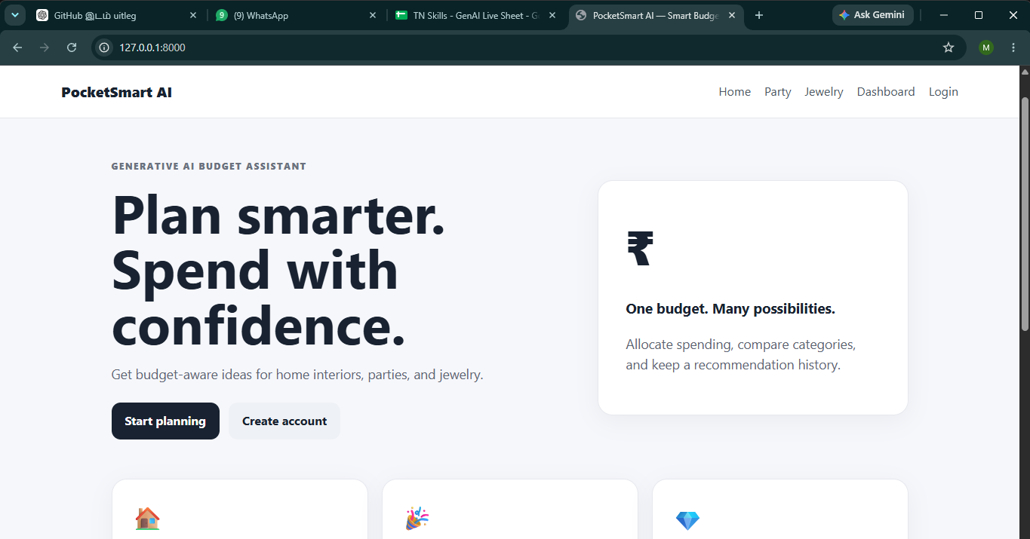
Figure 1. Home Page – Hero Section
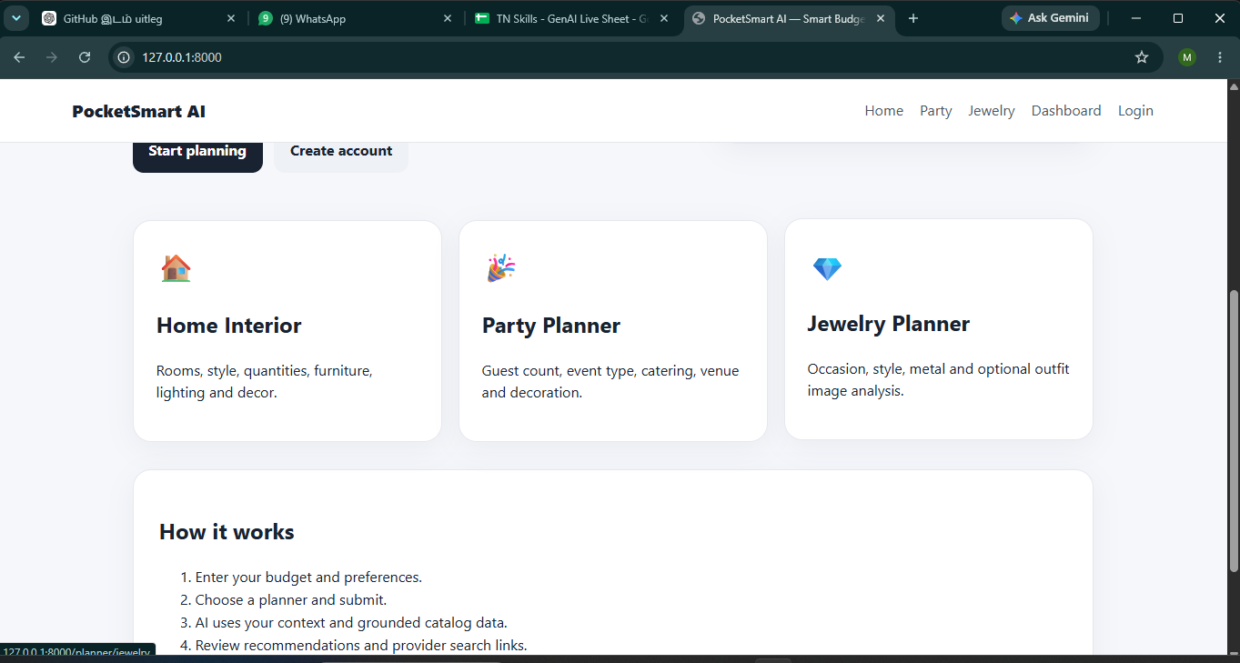
Figure 2. Home Page – Planner Features
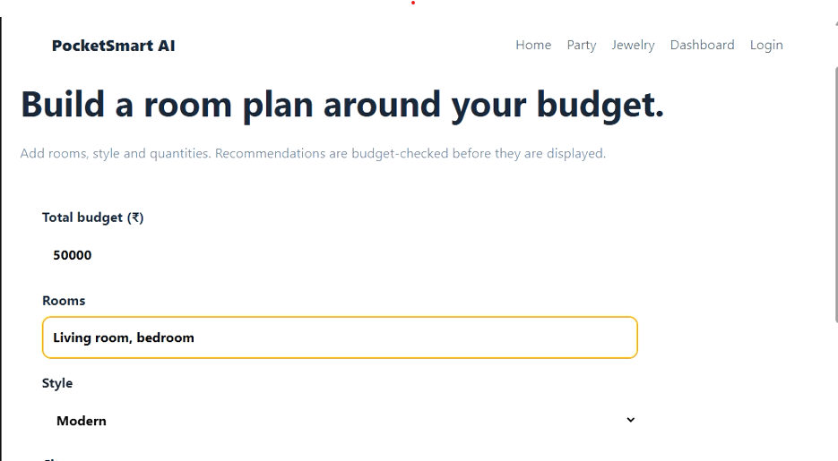
Figure 3. Home Planner – Input Form
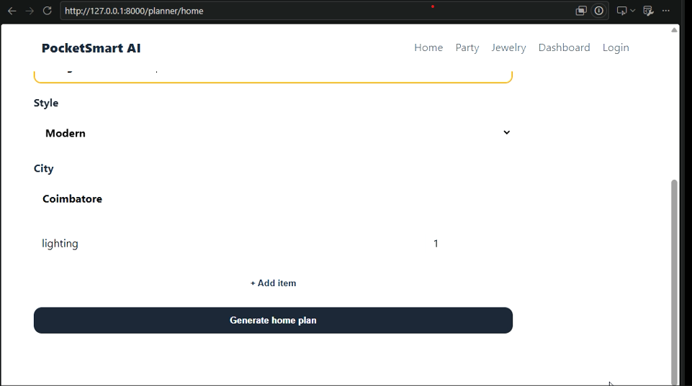
Figure 4. Home Planner – Form Details
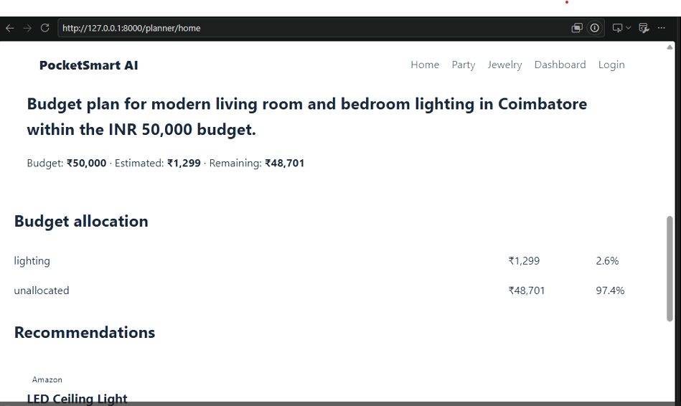
Figure 5. Home Planner – Recommendation Summary
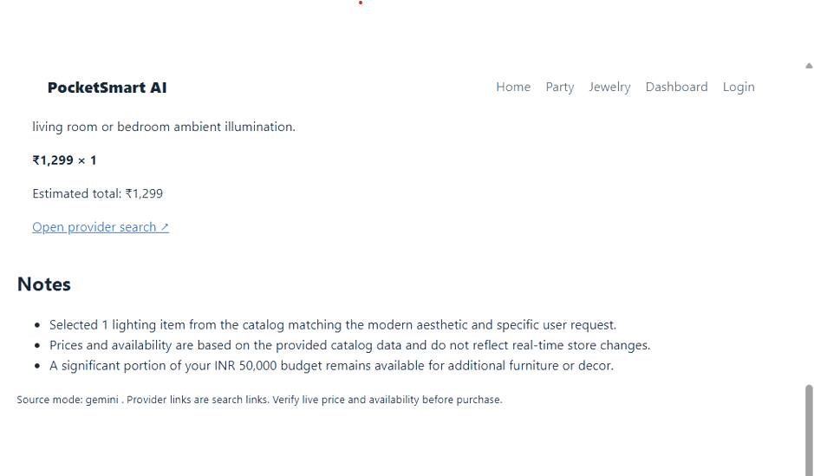
Figure 6. Home Planner – Recommendation Details and Notes
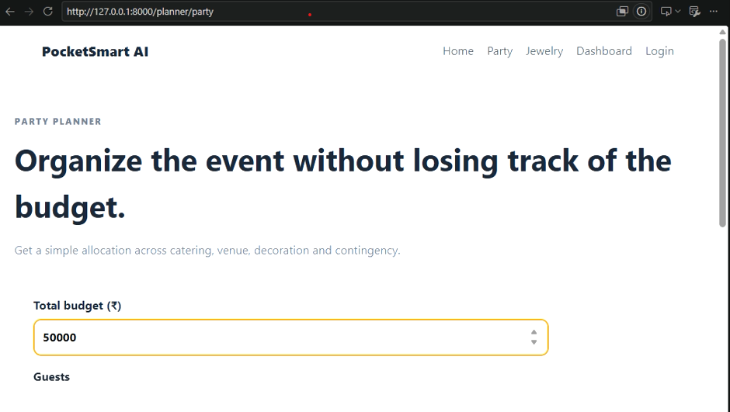
Figure 7. Party Planner – Input Form (Budget)
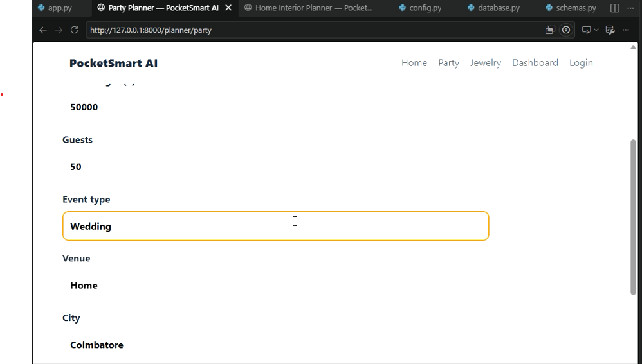
Figure 8. Party Planner – Guest Count, Event Type, Venue and City
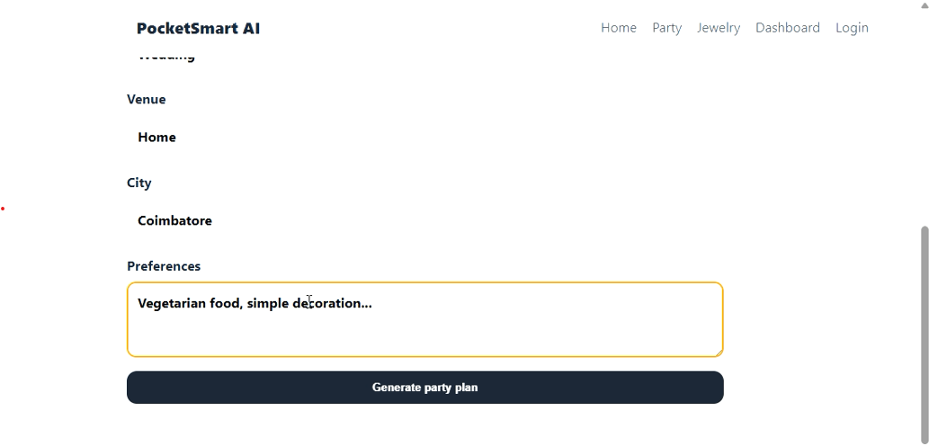
Figure 9. Party Planner – Preferences and Generate Action
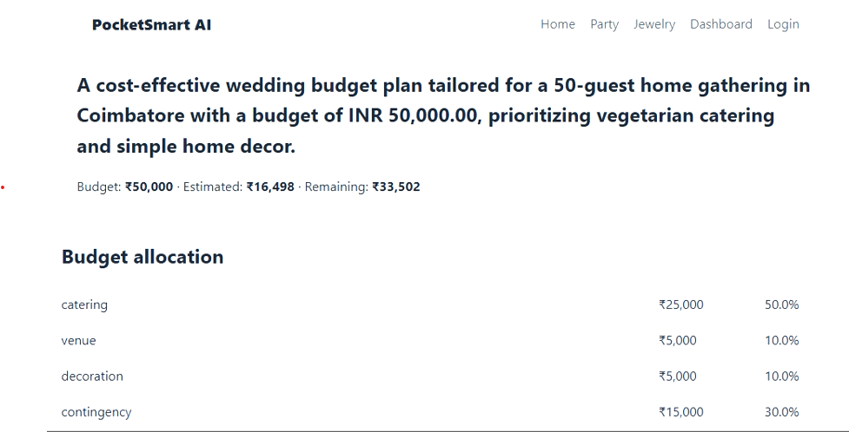
Figure 10. Party Planner – Budget Summary and Allocation
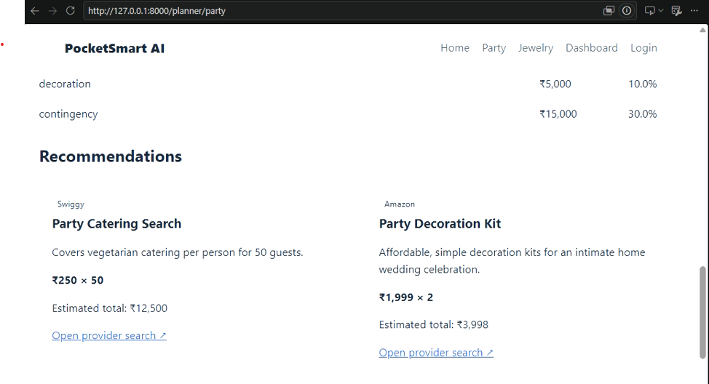
Figure 11. Party Planner – Recommendations
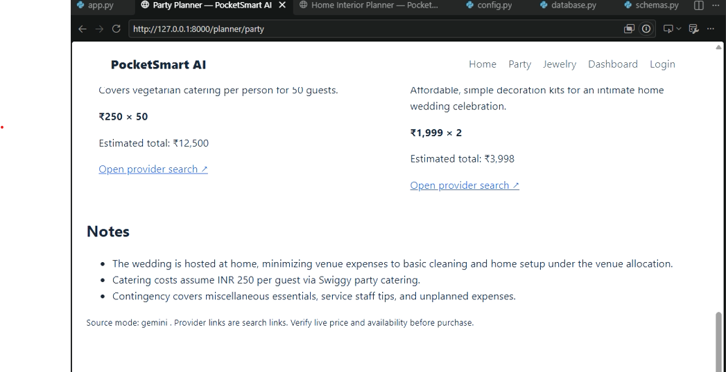
Figure 12. Party Planner – Notes
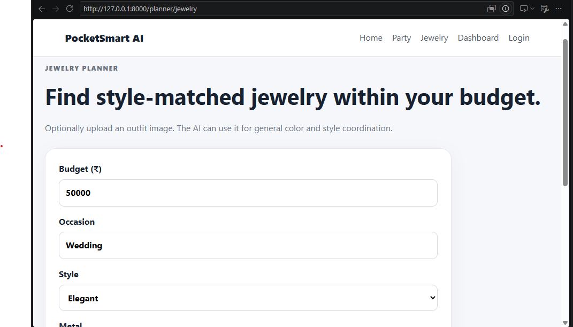
Figure 13. Jewelry Planner – Input
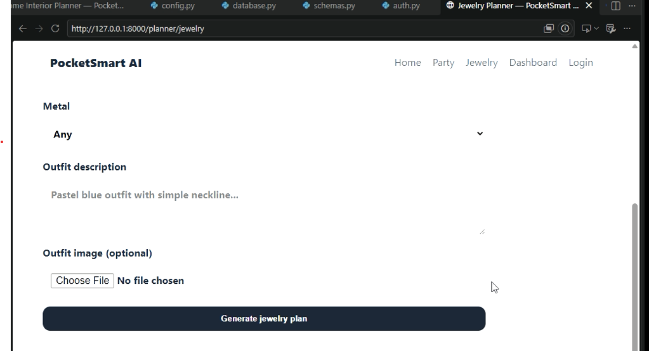
Figure 14. Jewelry Planner – Outfit Details
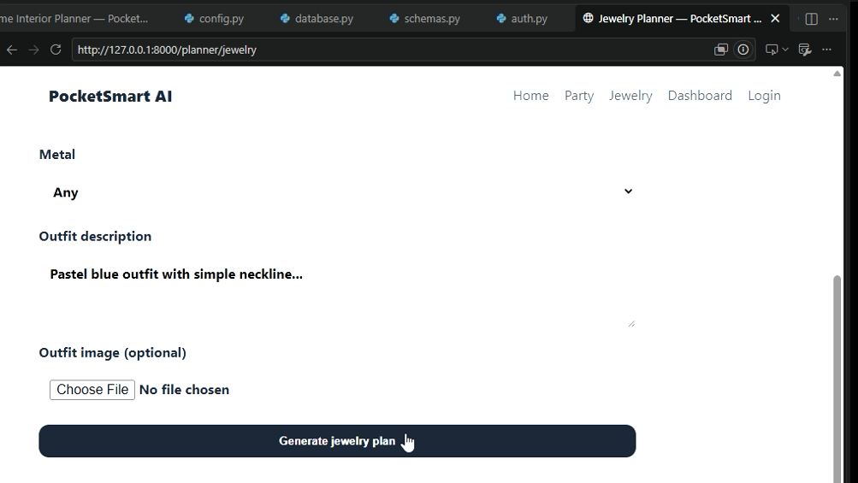
Figure 15. Jewelry Planner – Generate Action
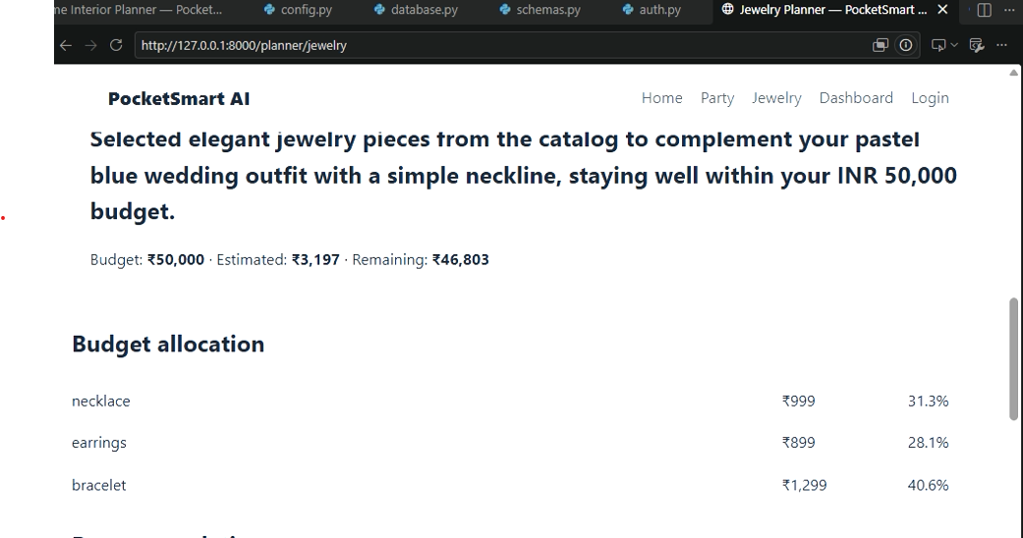
Figure 16. Jewelry Planner – Budget Allocation
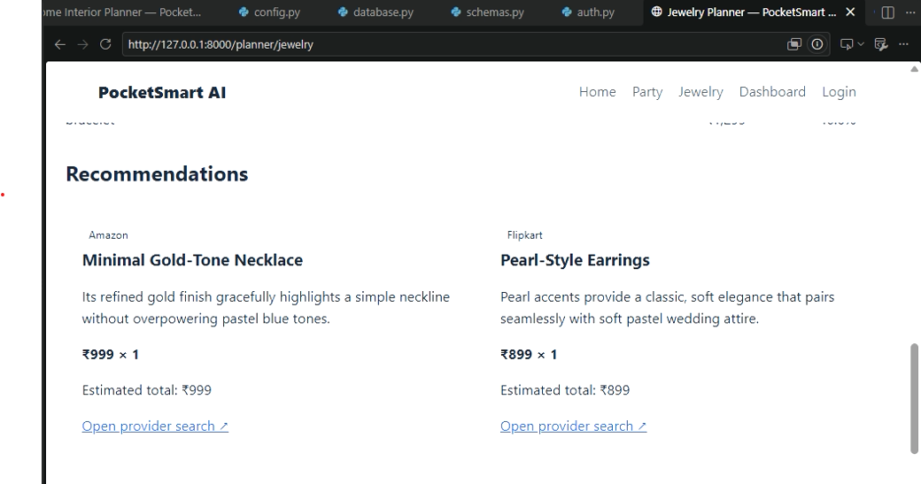
Figure 17. Jewelry Planner – Recommendations
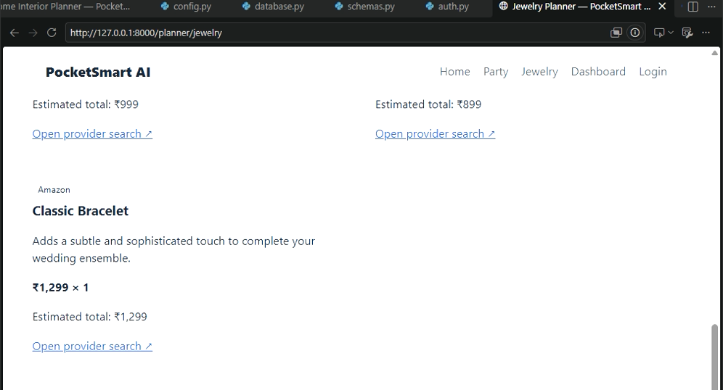
Figure 18. Jewelry Planner – Additional Recommendation
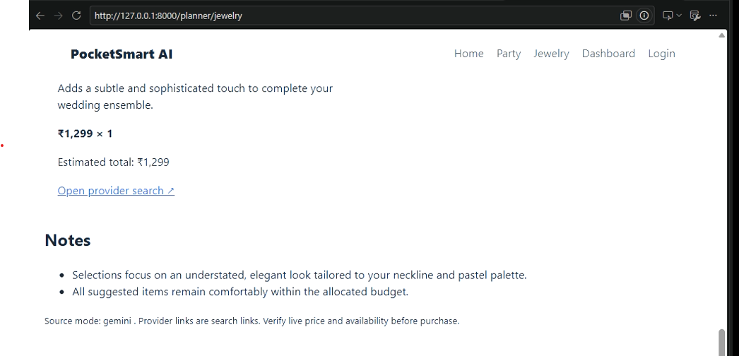
Figure 19. Jewelry Planner – Notes
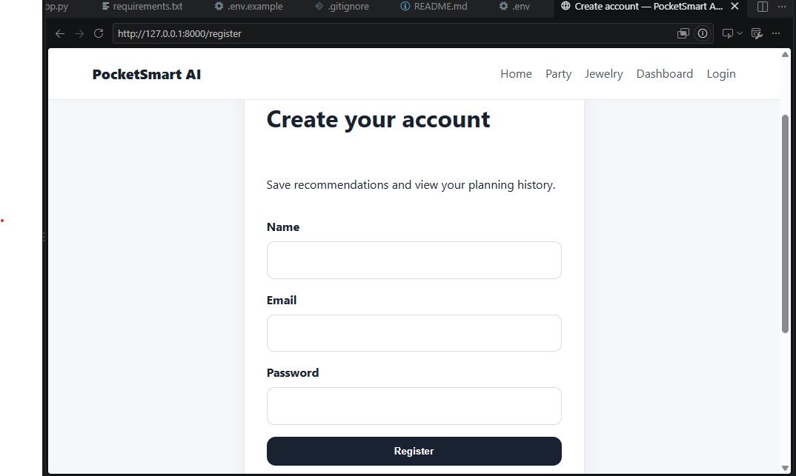
Figure 20. Registration Page
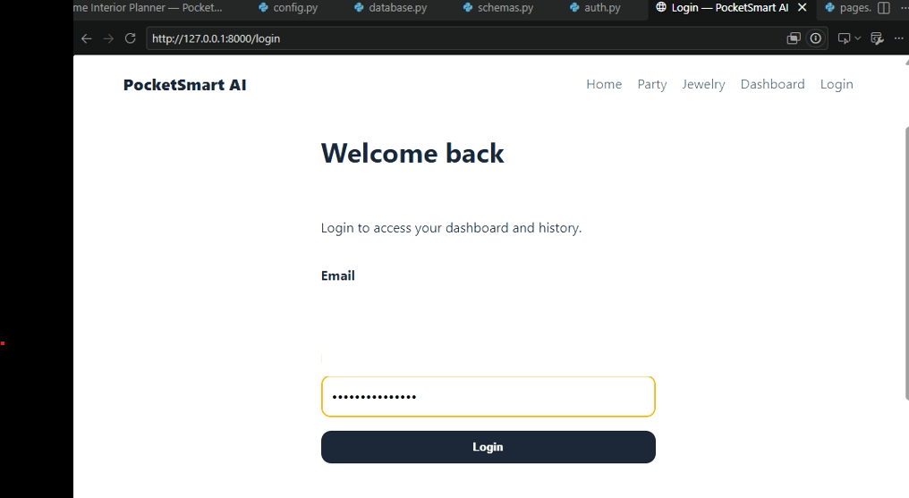
Figure 21. Login Page

Observed Output
- Home Planner example: INR 50,000 budget, displayed estimated total INR 1,299 and remaining INR 48,701.
- Jewelry Planner example: INR 50,000 budget, displayed estimated total INR 3,197 and remaining INR 46,803.
- Home output displays budget allocation, recommendations and provider search link.
- Jewelry output displays necklace, earrings and bracelet recommendations.
- Registration and login interfaces are included in the supplied screenshots.
- Party Planner example: INR 50,000 budget, 50 guests, Wedding event at Home in Coimbatore, displayed estimated total INR 16,498 and remaining INR 33,502.
- Party output displays budget allocation across catering, venue, decoration and contingency, along with catering and decoration provider recommendations and explanatory notes.

19. Limitations
- Recommendation links are provider search links rather than verified live product listings.
- Catalog prices are not guaranteed to reflect current store prices or availability.
- Gemini availability can affect AI generation; fallback logic is provided.
- The current setup is intended for local/development use.
- The supplied source does not include a separate test-execution report.

20. Future Enhancements
- Connect to official live product/service APIs where permitted.
- Improve recommendation filtering and category-specific ranking.
- Add more event types and home categories.
- Improve user profiles and saved plans.
- Add production-grade CORS and deployment configuration.
- Expand automated test coverage and CI.
- Provide downloadable budget plans/reports.
- Add additional languages and accessibility improvements.

21. Conclusion
PocketSmart AI demonstrates how Generative AI can be combined with a structured web application to support budget-aware planning. The supplied implementation combines FastAPI, Jinja2, JavaScript, SQLite, Pydantic validation, catalog grounding and Gemini-based structured generation.
The project covers Home Interior, Party and Jewelry planning and includes authentication, recommendation history, optional jewelry outfit image input, budget allocation, fallback recommendations and responsive result presentation. The supplied screenshots provide evidence of the implemented landing page, Home Planner, Party Planner, Jewelry Planner, registration and login interfaces.

22. References
- SmartBridge Project Document: PocketSmart AI – Your Smart Budget & Recommendation Assistant.
- Supplied PocketSmart AI source files and project structure.
- Google Gemini API integration as implemented in services/gemini_service.py.
- Project README.md and requirements.txt.

